Screenshots:
Figure 1: Hadoop HDFS and YARN services running successfully.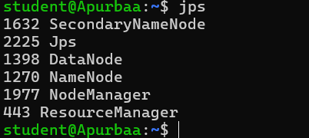

Figure 2: Sales dataset stored in HDFS.
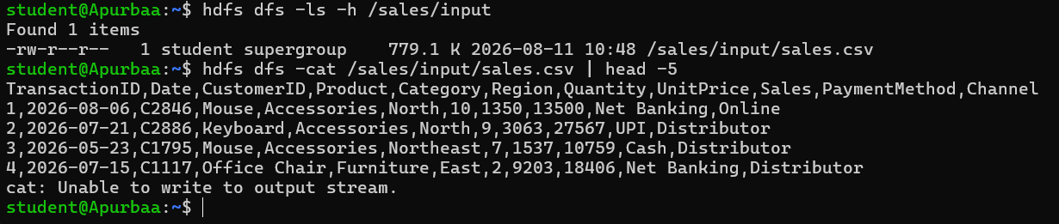

Figure 3: MapReduce output showing monthly sales trend.
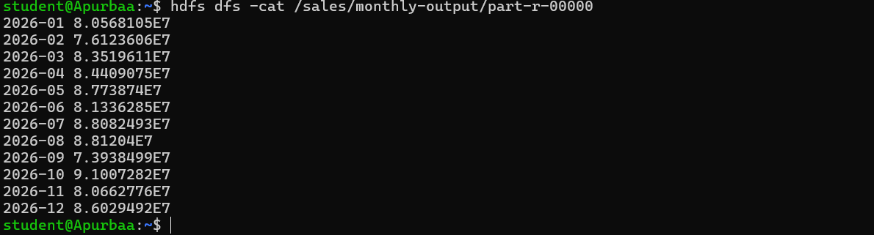

Figure 4: Regional sales analysis using Hadoop MapReduce.
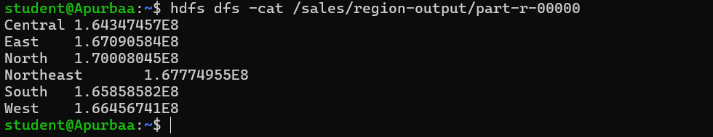

Figure 5: Sales distribution by product category.
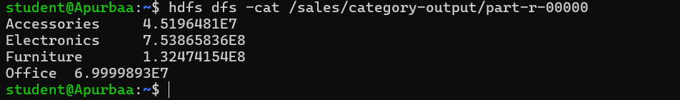

Figure 6: Sales contribution by sales channel.
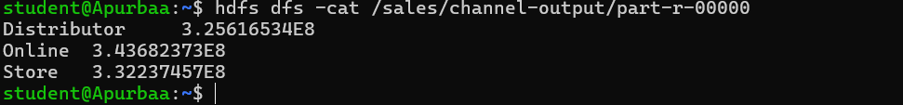

Figure 7: HDFS directories containing MapReduce analytical outputs.
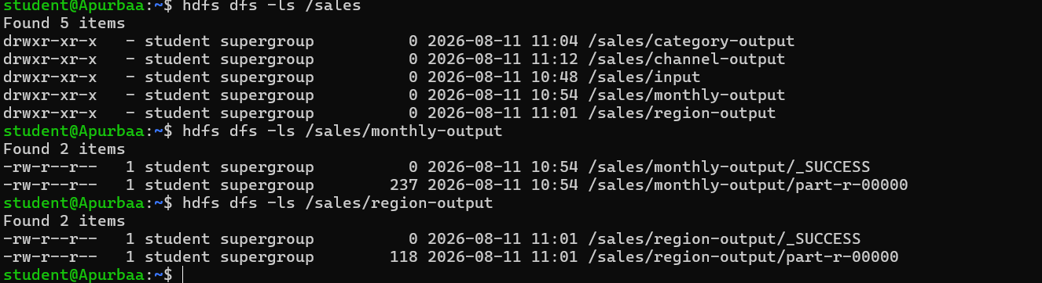

Figure 8: Completed MapReduce applications managed by YARN.
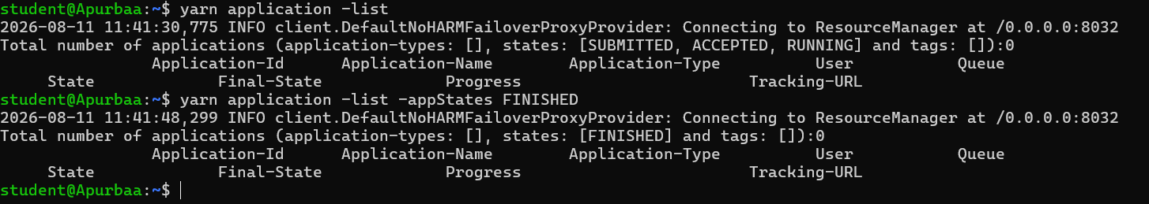

Java Source Code:
/home/student/RegionSales.java
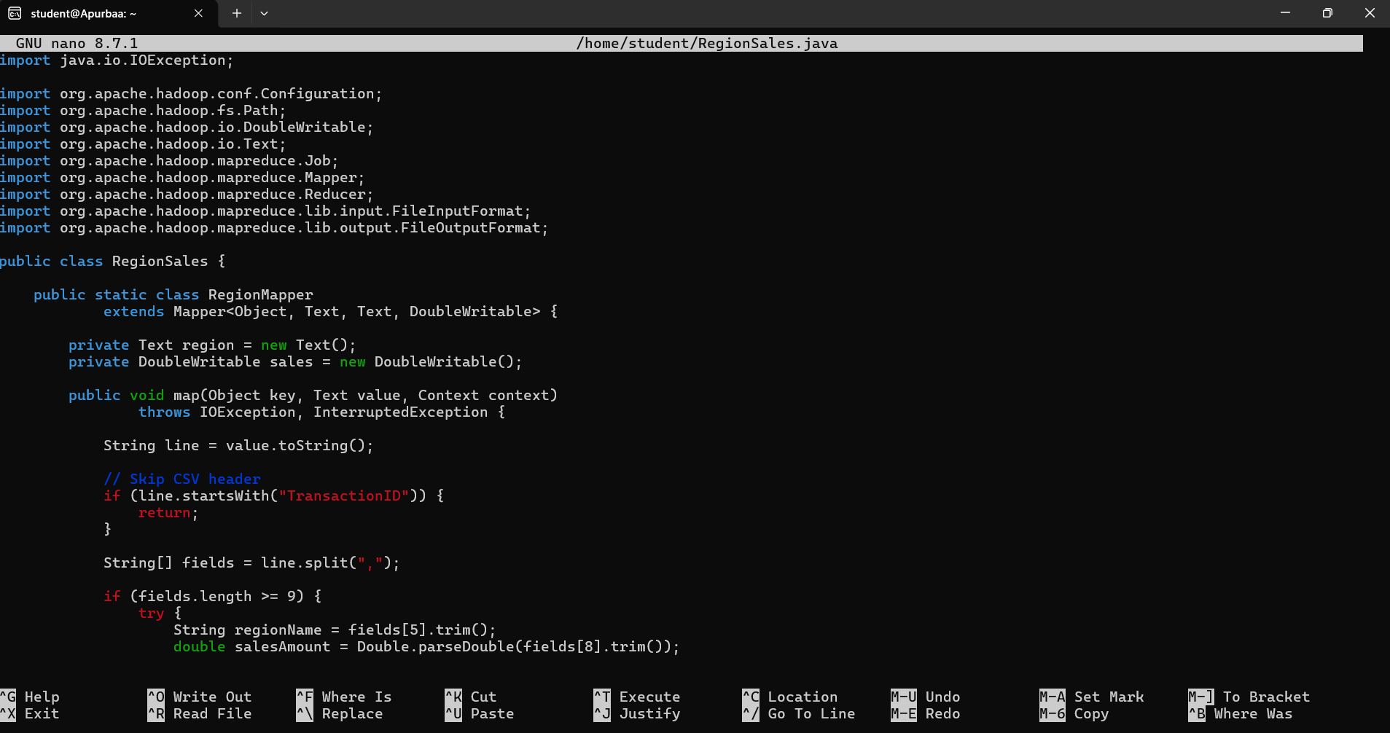

/home/student/ChannelSales.java
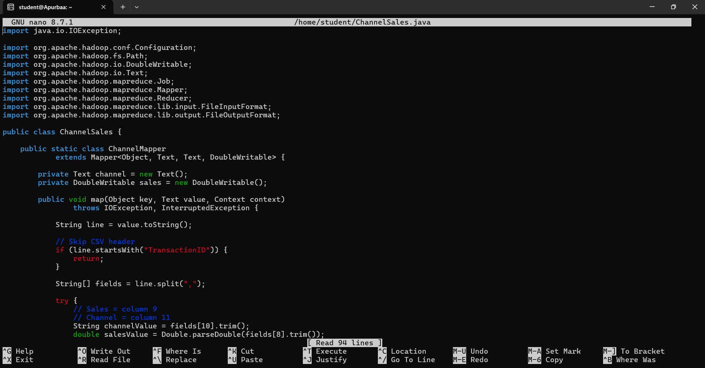

/home/student/CategorySales.java
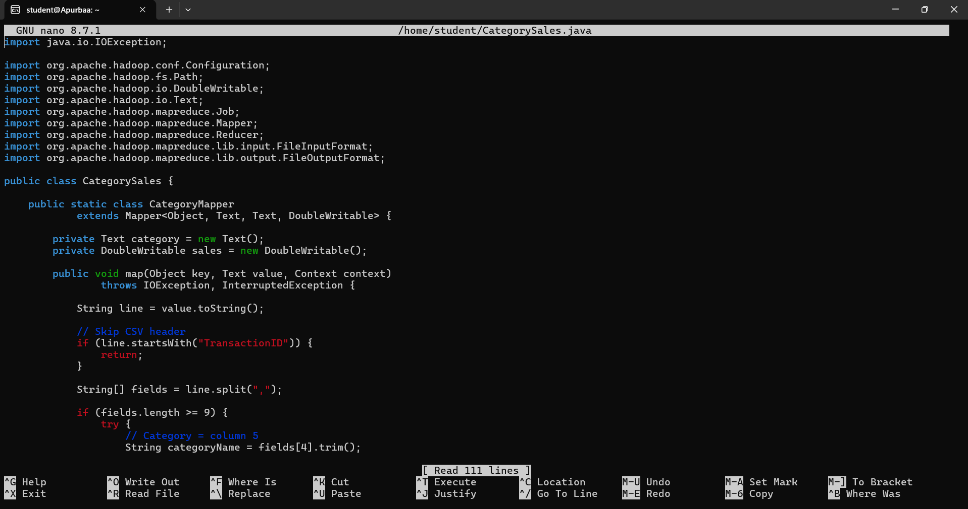

Successful MapReduce Execution:
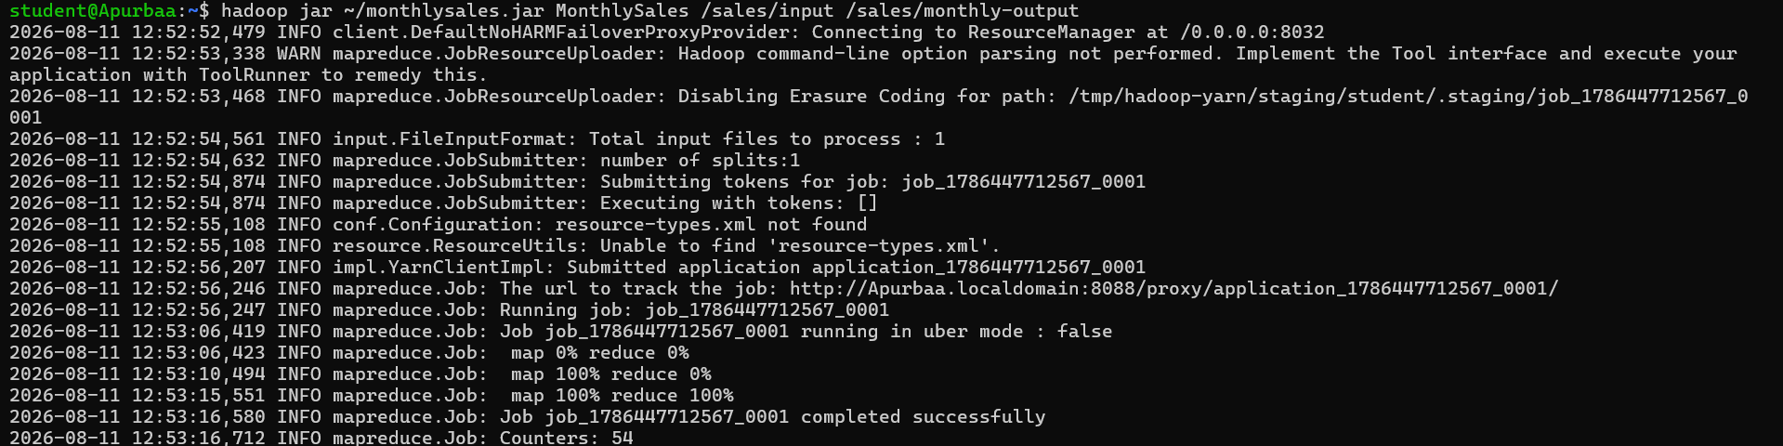

Explanation of HDFS, YARN and MapReduce
1. HDFS — Hadoop Distributed File System
HDFS is the storage component of Hadoop. It is used to store large datasets across the Hadoop system.
In this project, the sales.csv dataset was uploaded into HDFS so that Hadoop could process it.
For example:
hdfs dfs -mkdir -p /sales/input
hdfs dfs -put sales.csv /sales/input/
The dataset can then be checked using:
hdfs dfs -ls /sales/input
Role in the project:
HDFS stores the input sales.csv file and the output generated by the MapReduce programs.

2. YARN — Yet Another Resource Negotiator
YARN is Hadoop's resource-management and job-scheduling component. It manages the computer resources needed to run Hadoop applications.
When a MapReduce job is submitted, YARN:
- Allocates CPU and memory resources.
- Starts the required application processes.
- Manages and monitors the job.
- Coordinates execution across the Hadoop environment.
In simple terms:
HDFS stores the data, while YARN manages the resources used to process the data.

3. MapReduce
MapReduce is Hadoop's programming model for processing large datasets.
It normally works in two main stages:
Map → Shuffle/Sort → Reduce
For the sales dataset:
Map phase
The Mapper reads records from sales.csv and converts each record into a key-value pair relevant to the analysis.
For example, for monthly sales:
January → 12500
January → 8300
February → 15200
Shuffle and Sort
Hadoop groups values having the same key:
January → [12500, 8300]
February → [15200]
Reduce phase
The Reducer combines the grouped values to produce the final result:
January 20800
February 15200
The results are then stored back in HDFS, for example:
/sales/monthly-output/part-r-00000

How they work together
Your project can be described as:
sales.csv
↓
HDFS
↓
MapReduce Job
↓
YARN
(manages resources)
↓
Mapper
↓
Shuffle & Sort
↓
Reducer
↓
Output
↓
HDFS

